
Project Initialization and Planning Phase

Date | 13 July 2026
Team ID | xxxxxx
Project Name | Personalized Networking Assistant
Maximum Marks | 3 marks

Define problem statement:

"I am a student or professional attending networking events, conferences, or career fairs. I'm trying to build meaningful professional connections by starting relevant conversations, verifying information about event topics, and improving my networking skills over time. But I struggle to initiate engaging conversations, quickly verify facts, and remember which networking strategies worked best because I lack personalized conversation guidance, reliable information in one place, and a system to track my previous networking experiences. This makes me feel nervous, less confident, and worried about missing valuable networking opportunities and making a poor impression."

Example:
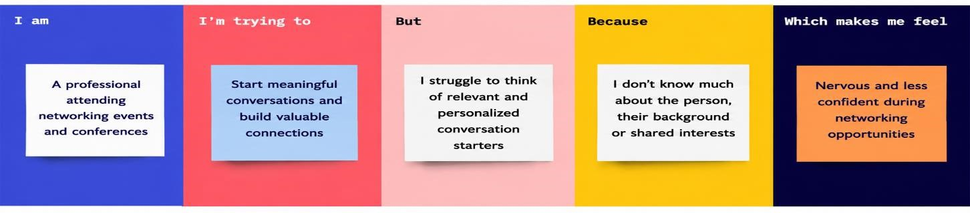

Problem Statement | I am (Customer) | I'm trying to | But | Because | Which makes me feel
PS-1 | A professional participating in seminars and conferences. | Build meaningful  professional connections | I often struggle to start  conversations with new people | I do not know enough about common  discussion  topics or shared interests | Nervous and less  confident during  networking events
PS-2 | A student attending technical events and career fairs. | Network with industry  experts and peers | I find it difficult to identify relevant  conversation topics | I lack experience and confidence in professional networking | Anxious and hesitant to engage with others
PS-3 | A job seeker who regularly attends networking events. | Create a strong professional impression | I am unsure about how to  begin or maintain conversations | Every event has different themes and audiences | Stressed and uncertain about my  networking skills

